# Fathima Hussain

BCA Student | Sri Krishna Adithya College of Arts and Science

* 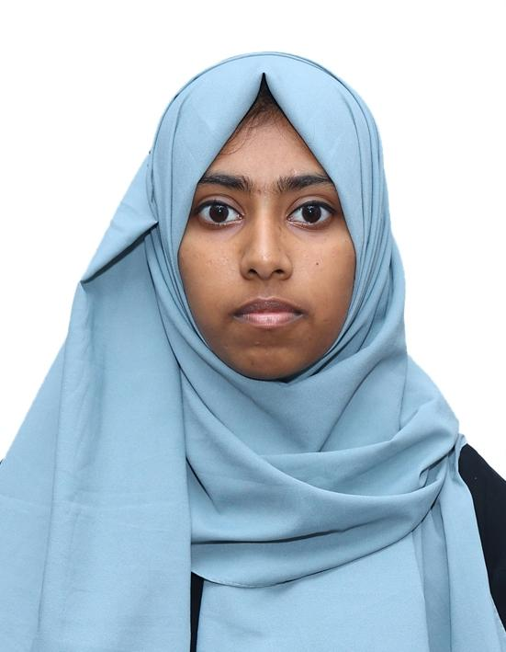About
* Education
* Projects
* Skills
* Internship
* Achievements
* Contact

## About Me

I am a Computer Applications student at **Sri Krishna Adithya College of Arts and Science**. I am passionate about technology, problem solving, and continuous learning. I aim to grow my skills in programming, design, and modern computing technologies.

## Education

**Bachelor of Computer Applications (BCA)**

Sri Krishna Adithya College of Arts and Science

## Projects

* Calculator based on Economic Calculations

## Skills

* Python
* SQL
* UI/UX Design

## Internships

* UI/UX Design Internship

## Achievements

* Certification in Cloud Computing
* Certification in Cyber Security
* Certification in Python Programming

## Contact

Email: [24bsca109fathimahussain@skacas.ac.in](mailto:24bsca109fathimahussain@skacas.ac.in)

Phone: 7034366629

© 2025 Fathima Hussain | Portfolio